
Annenberg (ASC) is Across from Heritage Hall: The Future Starts Here!
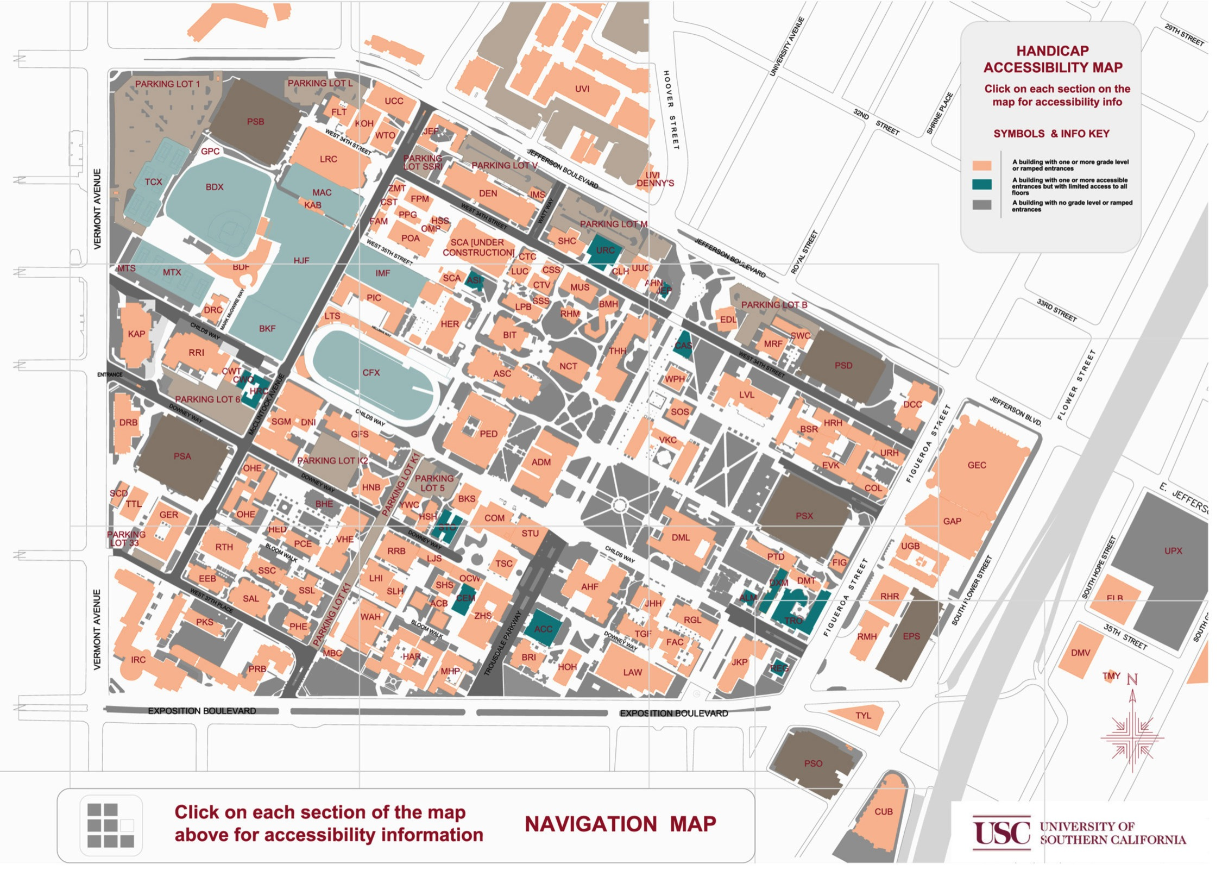
- 1:00 Introductions/housekeeping Lab Team
- 1:10 Goals for the Day Patti & Debbie
- 1:15 VUCA and Foresight Patti
- 1:35 Process Instructions Lab Team
- 1:45 Scenario Affirmation Groups All

- 2:45 Break
- 3:00 Scenario Story Board Prep All

- 3:30 Scenario Presentations/Q&A All
- 4:15 Drivers/Debriefing Patti & Team
- 4:45 The Way Forward Debbie & Robin

USC 2024

AGENDA

Mar. 14, 2014

1:00 pm -5:00 pm

ASC 207

